

Items highlighted in yellow are tasks for you to complete
Items in Blue are help tips

MWP 132 Create a letterhead

Session Tasks - Create a letterhead

1. Open Microsoft Word create a page in portrait A4 size
2. Use your existing product details to create a Letterhead
3. Add text box change colour and fit the box as header
4. Insert another text box and type text which should be put over the first text box, this is the details of your letterhead, it should incorporate:
Name of Company, address, phone, web and Email details
5. Your page needs some colour down one side or across the top to add impact

Create company letterhead using Word
Applies to
Microsoft Office Word 2003
Microsoft Word 2002
To learn more about how to accomplish this specific task with a different Microsoft Office program that is designed for the job you're doing, follow the links in the See Also section of this article.
If you create business letters, you can use Word to develop your company's letterhead. Rather than follow the standard format for writing business letters, in which your company's address is listed first, you can use the Header and Footer feature in Word to add company information, including a small logo.

Breaking away from the standard business letter format
In a standard business letter, information is typically left-justified and flows down the page in the following order:
- Name (optional) and address of the company that the author is representing
- Current date
- Recipient's address
- Greeting to open the letter, such as "To Whom It May Concern"
- Body of the letter, containing two to five paragraphs
- Closing remark, such as "Sincerely"
- Four lines of space for the author's signature
- Author's name
- Author's title, such as "Senior Business Manager" (optional)
Alternatively, your business letter format can begin with the date (from number 2 in the list above), and the following company information can reside in the header of your document:
- Company name
- Company address
- Telephone number
- Fax number
- E-mail address
You can then make your letterhead attractive and format it differently from the rest of your letter. For example, if the body of your letter is in font type Arial in 12 point and the font color is black, you might make the address in your letterhead Arial 8 point and blue. In the footer, you can also add your company's mission statement, logo, or some other important message. See the graphic below.
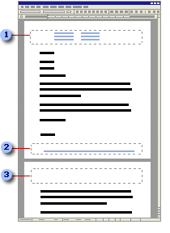
Company letterhead
Company message, such as "A. Datum Corporation is an equal opportunity employer."
Blank header on the second page of the document

Insert company letterhead
- On the View menu, click Print Layout.
- On the View menu, click Header and Footer.
- On the Format menu, click Tabs, click Clear All, and then click OK.
Clearing the default tabs set for the header and footer allows you to insert your letterhead information at any .5" interval.
- On the Formatting toolbar, choose the font type, font size, and font color you want.
- Press the TAB key twice, type the company name, press TAB again, and then type the company telephone number.
- Press the ENTER key to go to the next line, press TAB twice, and then type the company street number and name.
Note If you have a long street address, you may need to press TAB twice rather than once between each block of information in your header.
- Press TAB until your insertion point is aligned with the telephone number above, and then type the company fax number.
- Press ENTER, press TAB twice, and then type the company city, state, and ZIP code.
- Press TAB until your insertion point is aligned with the fax number above, and then type the company e-mail address.
- On the Header and Footer toolbar, click Close.

Insert company letterhead on page one only (recommended)
If you have a letter that is longer than one page and you do not want company letterhead to appear on each page, complete the following steps before you move on to the next procedure.
- On the File menu, click Page Setup.
- On the Layout tab, under Headers and footers, select the Different first page check box.

Insert company mission statement or logo in the footer
- In print layout view, on the View menu, click Header and Footer.
- On the Header and Footer toolbar, click the Switch Between Header and Footer button.
- On the Formatting toolbar, choose the font type, font size, font color, and alignment option you want.
- Enter the company message, mission statement, or logo.
- If your letter is longer than one page and you want the footer information to appear on each page, on the Header and Footer toolbar, click the Show Next button, and then enter the company message, mission statement, or logo.
- On the Header and Footer toolbar, click Close.
SAMPLES LETTERHEAD

6. Add a graphic from your product and place this in a text box in the header and footer area, make the graphic watermark or slightly transparent

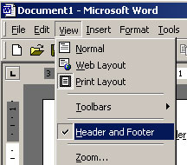

7. Select a picture and click on Format Picture
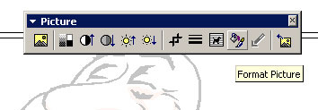

8. Make the picture Watermark or try other settings

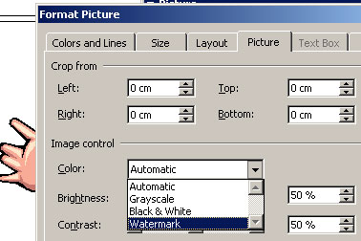

9. Save the file as letterhead.doc

At the End of this Lesson

Students will

- Plan and implement ideas for presentation
- Design and create a Presentation for a product
- Use skills to add images and animations
- Plan for a target audience based on a theme
Create a cover document made up of text and pictures

